Craig O’Neill

Elizabeth Chen

Population Trend Analysis

# Analysis of Trends

For initial population trend analysis we used data across all surveys and years. A total of 3,164 lakes were surveyed throughout Yosemite National Park and these lakes include some lakes which no adult Yellow-legged frogs have been observed during the survey period. Because of this, some lakes were not surveyed as often as other lakes.

Average population counts per year were used for this population trend analysis. Population counts per year were calculated by taking total abundance divided by the number of surveyed lakes in a given year. The average count per lake is used look at the overall abundance changes throughout the entire landscape.

Population trends for adults, sub-adults, and tadpoles were calculated independently and for each life stage. We are interested in incorporating the abundances of each life stage in a predictive model, though I am not quite sure how to incorporate this into our model yet. Overall analysis of the population trends for the entire set of surveyed lakes showed positive linear logistic growth for all life stages of the Yellow-legged frog (*Table 1*).

This initial analysis of the population trends is similar to the rates observed in Knapp’s paper (Knapp, et al., 2016) with our calculated rates falling within the 95% confidence intervals of the analysis that he conducted. His model is significantly more robust and takes into account additional predictor variables, covariate interactions, as well as random effects that account for spatial variability in abundance counts, and fixed effects to account for other factors that may affect abundance counts (such as time of day of survey). He also used two different distributions (negative binomial and zero-inflated negative binomial) for his analysis. The robust of his modeling is beyond my current understanding, but hopefully as the class continues I will be able to modify our initial findings.

# Management Implications

Non-native stocked trout predate upon Yellow-legged frogs and are partially blamed for historic loss in abundance due to both direct predation and indirect predation through resource competition (National Park Service, 2017). Though artificial stocking of these fishes have ceased in Yosemite National Park since the early 1990s, populations of these fishes still exist in most lakes in which they were introduced. Sinking monofilament gill nets have been used with success to eradicate non-native fish populations from oligotrophic lakes in the Sierra Nevada region (Knapp & Kathleen, 1998).

By looking at the population increases across the different categories of lakes we can start to analyze how and in what conditions we are seeing the greatest increases in population abundance. These insights can be utilized to understand the source causes that are contributing to the large scale recovery of an endangered amphibian population and whether these actions can be applied to other populations.

# Additional Population Trend Analysis

To get into the main question of our management implication I wanted to explore the effects of various environmental factors, such as non-native fish stocking, has had on the population of Yellow-legged frogs in Yosemite National Park. To do this, I attempted to sub-sample the data based upon lake status and create independent population trend analyses.

Unfortunately the linear models for SF and SFL lakes failed to significantly predict the abundance counts (*Table 2*), this may be an issue with the number of sampled data that I have for these lakes, or perhaps I am using incorrect modeling methodology.

The additional models were constructed by sub setting the survey information based upon a singular lake characteristic: The status of fish stocking populations. Lakes were characterized by the original survey as either having populations of stocked fish (“SF”), previously having had populations of stocked fish but no longer having any fish (“SFL”), and lakes which never had any stocked fish (“No”). The goal of these additional models was an attempt to look at what was driving the increase in frog abundance despite historical records showing that this frog has been in decline.

Lastly, I attempted to subset the number of surveys to only those surveys which occurred for lakes which had at least 5 years of data. The number of surveys per lake over the 20 year period ranges from 2 to 55. This reduced the amount of lakes analyzed down to 353 lakes. This model was used to try and look at the sensitivity of the models and to begin to investigate if a lack of survey years was a contributing factor to the SF and SFL lake models not being significant (*Table 2*).

Table 1. **Summary of Logistic Growth Rate.** A linear regression model was constructed which looked at average abundance of Yellow-legged frogs across all three of its life stages (Adult, Subadult, and Tadpole) per lake throughout Yosemite National Park. The model showed positive growth rates for all life stages.

|  |  |  |  |  |
| --- | --- | --- | --- | --- |
|  |  | ***Adult*** | ***Subadult*** | ***Tadpole*** |
| All Years, All Surveys, All Data | *Log Growth Rates* | 0.21228 | 0.16667 | 0.243022 |
| *95% Confidence Interval* | (0.139, 0.285) | (0.102, 0.231) | (0.148, 0.338) |
| *Measurement Error Variance* | 0.80658361 | 0.62615569 | 1.354896 |
| *P-Value* | <0.0001 | <0.0001 | <0.0001 |

Table 2. **Summary of Model Parameters.** Linear regression model was fit for average population counts per lake within Yosemite National Park (log abundance / surveyed lakes per year). The model predicts positive linear growth for all life stages of the Sierra Yellow-legged frog. Multiple variations of the model was developed to capture different categories of lakes found within Yosemite. SFL Lakes refer to lakes which were artificially stocked with trout but at the time of the survey period no longer contained trout (either by removal via gillnets, or due to the cessation of artificial stocking); SF Lakes are lakes which were artificially stocked and fish populations remain self-sustaining despite the cessation of stocking; and Fishless lakes are lakes which have never experienced artificial stocking.

|  |  |  |  |  |
| --- | --- | --- | --- | --- |
|  |  | ***Adult*** | ***Subadult*** | ***Tadpole*** |
| All Lakes, At Least 5 Years of Data Per Lake | *Log Growth Rates* | 0.13329 | 0.10373 | 0.18439 |
| *95% Confidence Interval* | (0.07, 0.20) | (0.05, 0.16) | (0.07, 0.29) |
| *Measurement of Error Variance* | 0.68657796 | 0.50808384 | 1.833316 |
| *P-Value* | 0.000604 | 0.001457 | 0.002491 |
| All Years, SFL Lakes Only | *Log Growth Rates* | 0.09969 | 0.05432 | 0.10193 |
| *95% Confidence Interval* | (-0.006, 0.205) | (-0.069, 0.177) | (-0.039, 0.242) |
| *Measurement of Error Variance* | 1.371241 | 1.844164 | 2.719201 |
| *P-Value* | 0.063333 | 0.3608 | 0.1436 |
| All Years, SF Lakes Only | *Log Growth Rates* | 0.1233 | 0.05138 | -0.05485 |
| *95% Confidence Interval* | (-0.037, 0.285) | (-0.099, 0.202) | (-0.389, 0.280) |
| *Measurement of Error Variance* | 1.855044 | 0.68674369 | 3.732624 |
| *P-Value* | 0.1172 | 0.3971 | 0.6724 |
| All Years, Fishless Lakes Only | *Log Growth Rates* | 0.20745 | 0.16682 | 0.23912 |
| *95% Confidence Interval* | (0.132, 0.283) | (0.099, 0.235) | (0.141, 0.337) |
| *Measurement of Error Variance* | 0.42068196 | 0.70090384 | 1.452025 |
| *P-Value* | <0.0001 | <0.0001 | <0.0001 |
| All Years, All Surveys, All Data | *Log Growth Rates* | 0.21228 | 0.16667 | 0.243022 |
| *95% Confidence Interval* | (0.139, 0.285) | (0.102, 0.231) | (0.148, 0.338) |
| *Measurement of Error Variance* | 0.80658361 | 0.62615569 | 1.354896 |
| *P-Value* | <0.0001 | <0.0001 | <0.0001 |

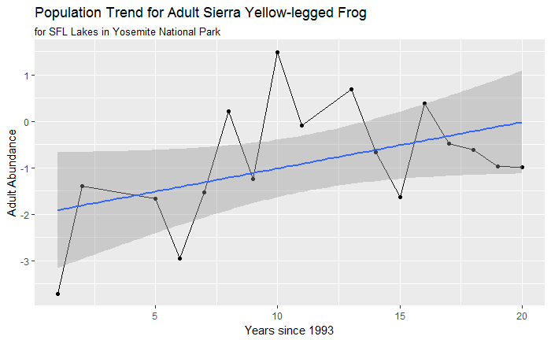

Figure 1. **Population Trend for Adult Sierra Yellow-Legged Frog within Stocked but Fishless Lakes.** Log Abundance of Adult Sierra Yellow-legged Frogs showed a linear upward trend of 0.09969 per year with a 10% significance level (p-value = 0.06333) for lakes which have historically been stocked, but no longer have any current fish populations.

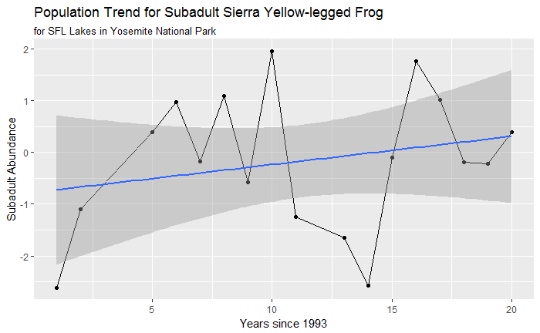

Figure 2. **Population Trends for Subadult Sierra Yellow-Legged Frog in SFL Lakes.** The population trend for subadult Yellow-legged frogs shows an increase of 0.05432 in log abundance per year.

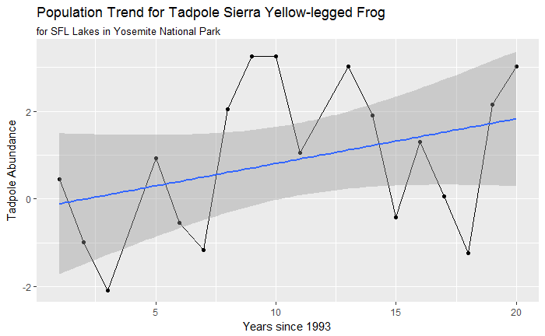

Figure 3 **Log Abundance Trend for Tadpoles in SFL Lakes.** Lakes which were previously stocked with fish but no longer contained fish during the survey period showed an increasing trend in log abundance for Yellow-legged tadpoles.

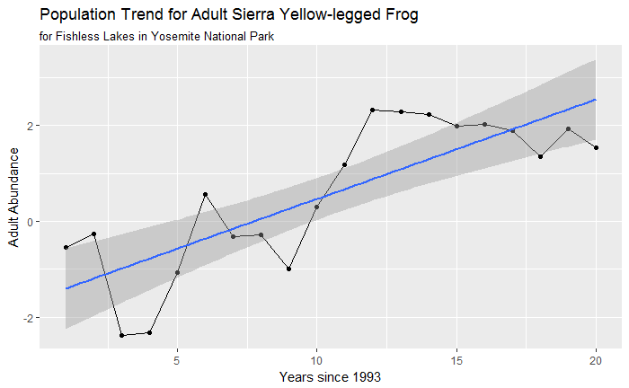

Figure 4 **Log Abundance Trend for Adult Sierra Yellow-Legged Frog in Fishless Lakes.** Fishless lakes are lakes located within Yosemite Valley that, as far as fish populations are concerned, most closely match the natural conditions of the lakes. These lakes have never been stocked with non-native fish and contain the highest abundances of Yellow-legged frogs in Yosemite National Park.

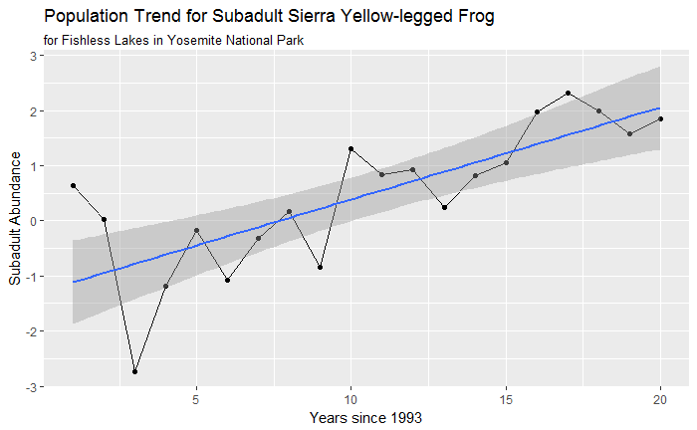

Figure 5 **Log Abundance for Subadult Yellow-Legged Frogs in Fishless Lakes**

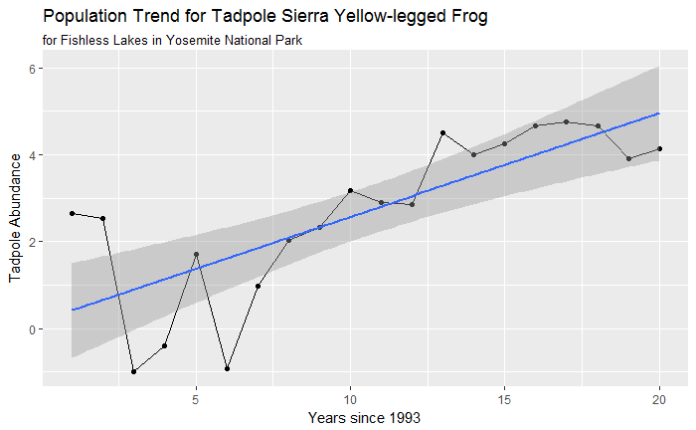

Figure 6 **Log Abundance for Tadpoles in Fishless Lakes**

# References

Knapp, R. A., & Kathleen, M. R. (1998). Eradication of Nonnative Fish by Gill Netting from a Small Mountain Lake in California. *Restoration Ecology, 6*(2), 207-213.

Knapp, R. A., Fellers, G. M., Kleeman, P. M., Miller, D. A., Vredenburg, V. T., Rosenblum, E., & Briggs, C. J. (2016, October). Large-scale recovery of an endangered amphibian despite ongoing exposure to multiple stressors. *Proceedings of National Academy of Sciences, 42*(113), 11889 - 11894.

National Park Service. (2017, August 31). *Fish*. Retrieved from National Park Service Yosemite: https://www.nps.gov/yose/learn/nature/fish.htm